You have been tasked with creating a coffee menu for a client where customers can order items from the menu, specify how many they want, and the program will output a total price for all items.

The menu has been provided as an image so it must be used.

The customer does not need to specify which item they wish to order, they should only increase or decrease the amount of each item they want and click purchase to be given the total price.

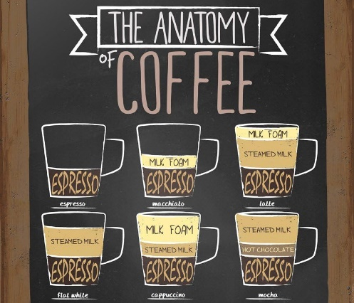

The total price of your order is £#

…

Macchiato £3.40

Espresso £2.70

quantity

+

-

-

+

quantity

Total

The prices for the items are:

* Espresso £2.70
* Macchiato £3.40
* Latte £3.30
* Flat White £3.20
* Cappuccino £3.60
* Mocha £3.90

**STRETCH** {

Instead of only presenting the total, build an item list similar to a online shop’s checkout page.

Change the button total to add.

As an example, if the user adds 2 to quantity of Espresso and 1 to Mocha, your new code should display above the total

Espresso 2 £2.70 £5.40

Mocha 1 £3.90 £3.90

Total £9.30

If the user then adds another Espresso, and a new single Latte, the info should change to

Espresso 3 £2.70 £8.10

Mocha 1 £3.90 £3.90

Latte 1 £3.30 £3.30

Total £15.30

As an extra stretch, add a method for the user to increase or decrease the quantity of an order with buttons on the checkout section, and one to remove the item completely

The x represents the button which would remove the item completely

Espresso 3 + - £2.70 £8.10 x

Mocha 1 + - £3.90 £3.90 x

Latte 1 + - £3.30 £3.30 x

Total £15.30

The brief does not specify the style of the website other than the layout of the menu and the image. It is entirely up to you how you choose to style the user interface.

}

To consider {

When creating the individual items of the checkout, think about which data structure can support multiple items, which also give you methods to find what the structure includes, map a function to all items, pop/remove an item, etc.

Because you are working with data which you also want to work on dynamically, think about what kind of structure supports storing data and the functions which you can apply to that data easily

}